Diagnostic and Wellness Center  at Harbor-UCLA Medical Center  Medical Director:  Matthew Budoff, MD FACC  Saint John’s Building 1st Floor  21840 Normandie Avenue, Torrance, CA 90502  Phone: 310 222 2773 Fax: 310 460 8963  www.CalciumScan.com  NPI 1821101015 Tax ID 33-0003558 | ^{Ordering Physician:}  Name:  Address:  Phone/ Fax:  Email:  X_________________________________________________  Physician Signature [required for Medicare/Insurance Beneficiaries]  Date of Request: ___________________________________  REPORT PREFERENCE: FAX MAIL EMAIL

ADVANCED LOW DOSE CT ORDER REQUISITION

Patient_______________________________________________ Phone__________________________________

Birth Date _______________ Age _______ Male Female Insurance _____________________ Auth: __________

Blood Pressure ____________________ Pulse ________________________ Weight____________________

CABG # of Vessels: _________ Stent # and vessels: _________ Creatinine: ______________ Date: ___________________

Chief Complaint: Diagnosis to be ruled out: Relevant ICD-10 (if known):

|____________________________________|___________________________________|_________________________________

Comments/Notes: ____________________________________________________________________________________________

CT ANGIOGRAPHY: CAROTID CORONARY CHEST RENAL RUN-OFF CT TAVR

71275 Chest CTA for Pulmonary embolism (I26.99) 70498 Carotid 73706 Low Extr Run-Off

71275 Chest CTA for Aortic Dissection (I17.01) 75635 Renal CTA 75635 Abd Aortagram AAA

75574 Coronary Angiography CTA 75573 Congenital Heart Disease specify _________________

75574 Coronary Angiography CTA with Wall Motion 75572 Pre-EP Studyno coronaries Other _________________

Other CT Services:
Chest Abdomen Pelvis Spine
71250 w/o contrast 74150 w/o contrast 72192 w/o contrast 72131 Lumbar w/o contrast
71260 with contrast 74160 with contrast 72193 with contrast
71270 with/ wo contrast 74170 with/wo contrast 72194 with/wo contrast
71275 Chest CTA/PE Study

Urogram Colon Other ________________
74170, 72194 with/ wo contrast 74261 Virtual Colonoscopy with without with/wo contrast

Wellness Screenings/ Other Services: *Covered by Medicare with medical necessity

75571 Coronary Artery Calcium (Heart)* 77078 CT Bone Density/BMD*

75571-77078 Heart and CT Bone Density/BMD* 71250-77078 Lung and CT Bone Density/BMD*

75571-71250-74176 Heart and Body Scan 0126-T Carotid Health Check - CIMT

75571-71250 Heart and Lung Scan 93306-Complete Echocardiogram

71250 Lung Scan* 74263 Colon/Virtual Colonoscopy*

GENERAL INSTRUCTIONS FOR ALL CT IMAGING

- Wear comfortable clothing. Avoid clothing with metal buttons or decorations.
- Arrive 15 minutes prior to your appointment.
- Bring this form and your insurance cards and/or completed paperwork (if received in advance).

INSTRUCTIONS CT OF ABDOMEN/PELVIS
- Drink plenty of water the day before, day of and day after the procedure.
- Light meals are permitted prior to your procedure.
- If you received a package of powder barium sulfate in advance, use 1½ hour before your appointment time follow mixing instructions on package. If you did NOT receive barium powder package, arrive at least 1 hour prior to your appointment time for this process.

INSTRUCTIONS FOR IV CONTRAST STUDIES
- Drink plenty of water the day before, day of and day after the procedure.
- Light meals are permitted prior to your procedure (important for diabetics).
- Provide lab results of recent BUN/CREATINE with date.
- Inform Diagnostic and Wellness Center-Harbor-UCLA of any allergies, past difficulties with contrast and/or IVs.

INSTRUCTIONS FOR CORONARY CT ANGIO ONLY
- Follow instructions as listed above 1-10 for contrast procedures.
- If taking any BETABLOCKERS such as Metoprolol, Propranolol, Tenormin, Inderal, Toprol, Lopressor, Atenolol – TAKE this medication as usual, preferably in the morning.
- If taking GLUCOPHAGE, METFORMIN, GLUCOVANCE, please DO NOT take this medication on the day of your procedure.
- If taking VIAGRA, LEVITRA, CIALIS – Please DO NOT take within 24 hours of procedure and 48 hours following.

INSTRUCTIONS FOR CT OF COLON ONLY
- Follow instructions and guidelines for LoSo Prep. These items are provided by Diagnostic and Wellness Center, Harbor-UCLA in advance and must be started 5 days prior to appointment.
- Do not eat any food prior to your procedure.
- If Diabetic, please inform Diagnostic and Wellness Center –Harbor-UCLA immediately.

www.CalciumScan.com
Directions to 21840 Normandie Ave, Torrance CA 90502 ~ CT Scanner Saint John’s Building
310.222.2773

- Off 110 FWY, Exit Carson Street, head West
- Left on Normandie Ave (traveling south), Left on 220th Street
- On 220th, turn left into first driveway, See CT Scanner and parking straight ahead
- Proceed to Saint John’s Building (south west area of medical center campus)
- Convenient RESERVED FREE Parking, Just Steps from Entrance of Building - CT Scanner
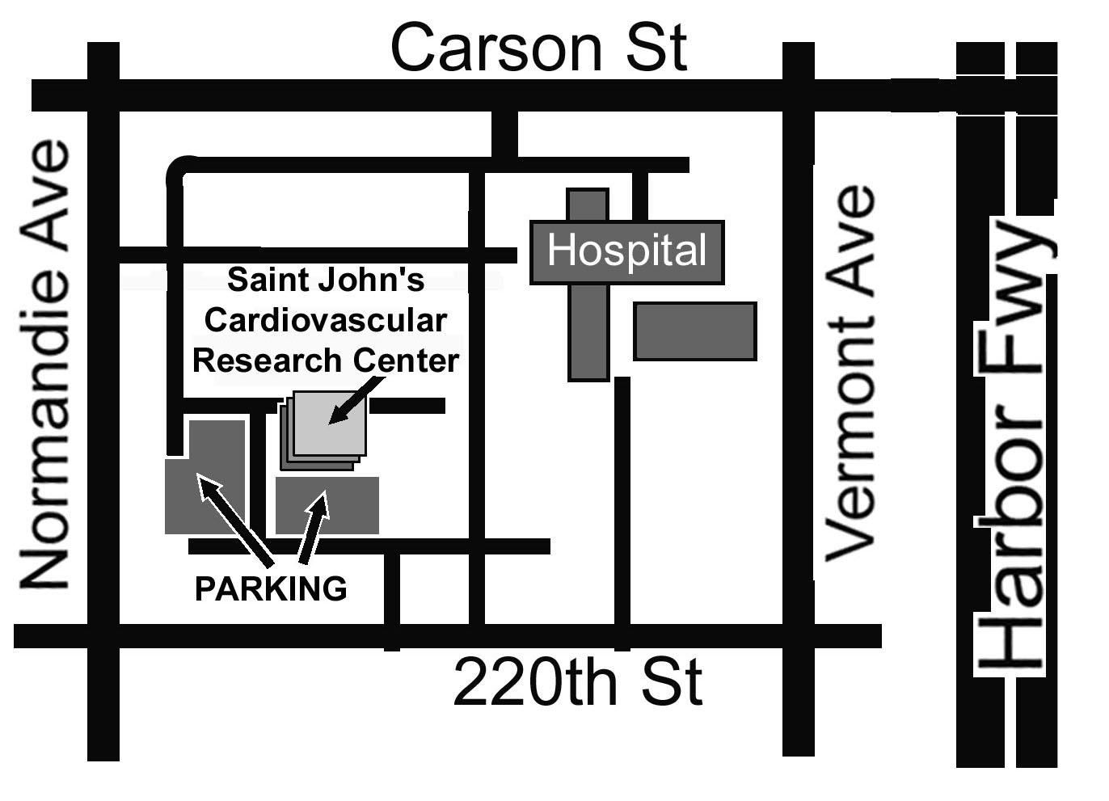
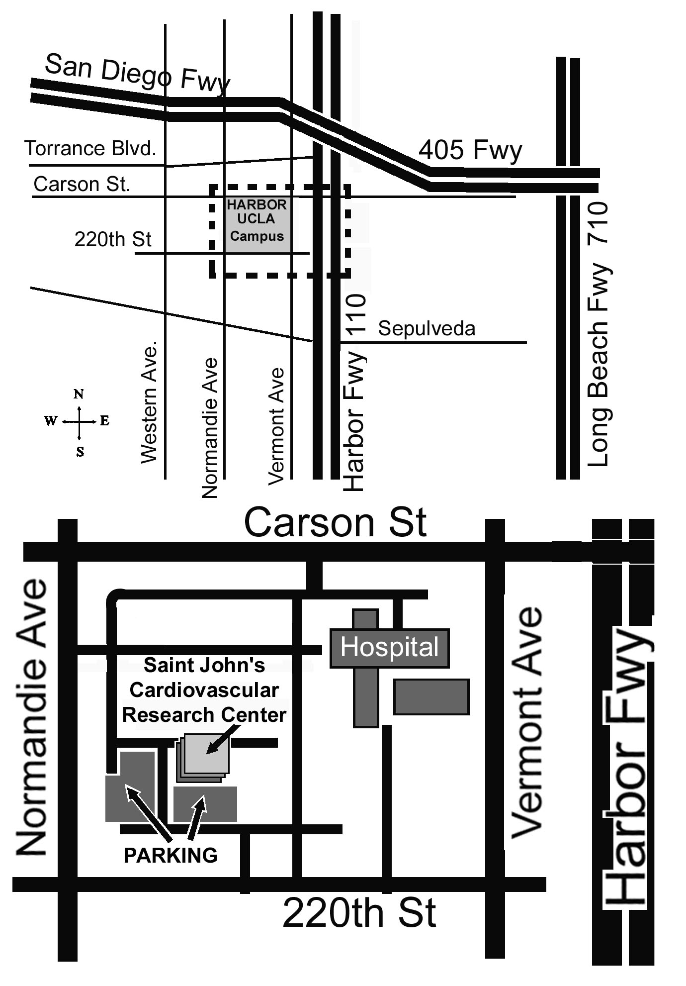
Saint Johns
CT Scanner

